EX. NO. 3 Write a Servlet program that prints “Hello, World!”
when accessed through a browser.

AIM:
To write a basic Servlet program that demonstrates the use of Java Servlets by printing
“Hello, World!” when accessed through a browser.
ALGORITHM:
1. Input:
The user makes an HTTP request (usually by entering a URL) through a browser.
2. Servlet Program Flow:
- Create a Servlet Class:
o Define a Java class that extends the HttpServlet class.
o Override the doGet() method, which handles HTTP GET requests from the
client (browser).
- Handle HTTP Request:
o In the doGet() method:
- Get the PrintWriter object to write the response to the browser.
- Set the response content type to text/html.
- Write the &quot;Hello, World!&quot; message to the response.
3. Compile the Servlet Class:
o Compile the Java Servlet file using the javac command to generate a .class
file.
4. Deploy the Servlet:
o Place the compiled servlet class file in the appropriate directory of the web
application (typically in the /WEB-INF/classes folder).
o Configure the servlet in the web.xml file of the web application or use
annotations.
5. Access the Servlet via Browser:
o Start the Apache Tomcat or another servlet container.
o Access the servlet by entering the appropriate URL (e.g.,http://localhost:8080/your-webapp/hello).

CODE:
Java:
import java.io.*;
import javax.servlet.*;
import javax.servlet.http.*;

public class HelloServlet extends HttpServlet
{
public void doGet(HttpServletRequest request,
HttpServletResponse response)
throws ServletException, IOException
{
response.setContentType("text/html");

PrintWriter out = response.getWriter();

out.println("<html><body>");
out.println("<h1>Hello, World!</h1>");
out.println("</body></html>");
}
}
web.xml:
<web-app>

<servlet>
<servlet-name>HelloServlet</servlet-name>
<servlet-class>HelloServlet</servlet-class>
</servlet>

<servlet-mapping>
<servlet-name>HelloServlet</servlet-name>
<url-pattern>/hello</url-pattern>
</servlet-mapping>

</web-app>

Output:
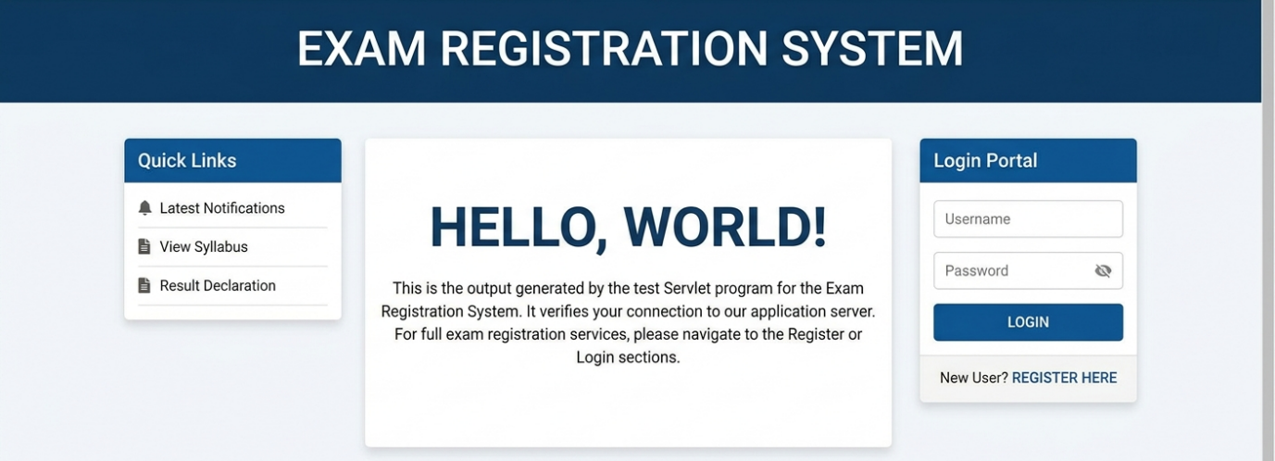
RESULT:
The browser will display the message “Hello, World!” returned by the Servlet.

